**Power BI – Assignment II : Connecting Data**

1. ***Data Transformation Output:***

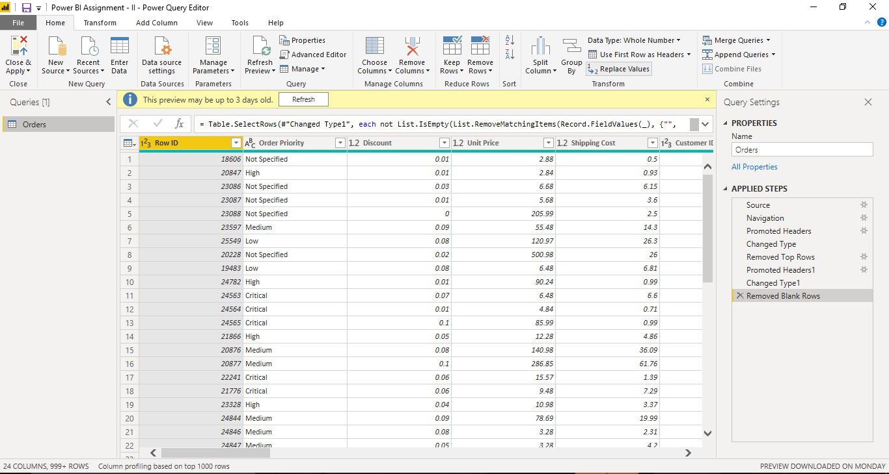

1. ***Screenshot Of Final Report :***

